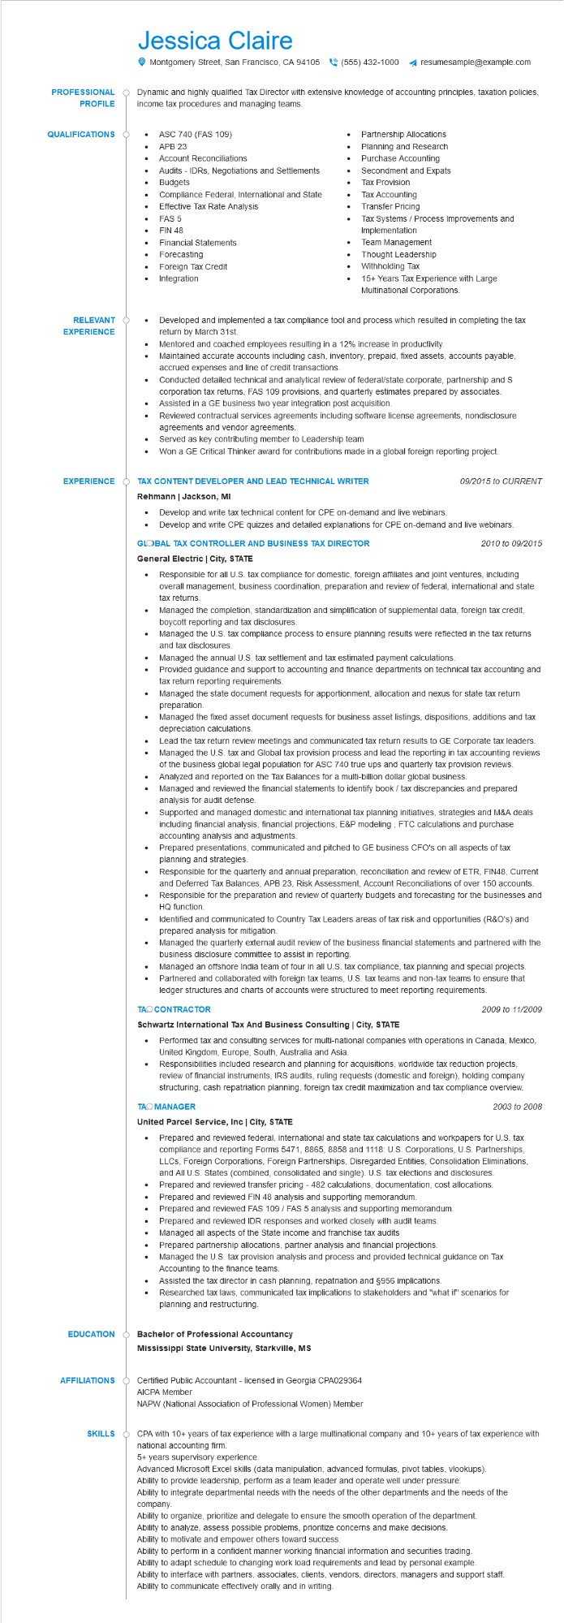
PROFESSIONAL
PROFILE
Jessica Claire
Montgomery Street, San Francisco, CA 94105(555) 432-1000 ◄ resumesample@example.com
Dynamic and highly qualified Tax Director with extensive knowledge of accounting principles, taxation policies, income tax procedures and managing teams.
QUALIFICATIONS O
• ASC 740 (FAS 109)
•
APB 23
• Account Reconciliations
Audits IDRS, Negotiations and Settlements Budgets
Partnership Allocations
•
Planning and Research
Purchase Accounting
Secondment and Expats
Tax Provision
Transfer Pricing
Tax Systems / Process Improvements and
Implementation
•
Compliance Federal, International and State Effective Tax Rate Analysis
•
Tax Accounting
FAS 5
·
FIN 48
Financial Statements
•
Forecasting
Foreign Tax Credit
•
Integration
RELEVANT O
•
EXPERIENCE
EXPERIENCE
•
•
Team Management
Thought Leadership
Withholding Tax
15+ Years Tax Experience with Large Multinational Corporations.
Developed and implemented a tax compliance tool and process which resulted in completing the tax return by March 31st.
Mentored and coached employees resulting in a 12% increase in productivity.
Maintained accurate accounts including cash, inventory, prepaid, fixed assets, accounts payable, accrued expenses and line of credit transactions.
Conducted detailed technical and analytical review of federal/state corporate, partnership and S corporation tax returns, FAS 109 provisions, and quarterly estimates prepared by associates. Assisted in a GE business two year integration post acquisition.
Reviewed contractual services agreements including software license agreements, nondisclosure agreements and vendor agreements.
Served as key contributing member to Leadership team
Won a GE Critical Thinker award for contributions made in a global foreign reporting project.
Ó TAX CONTENT DEVELOPER AND LEAD TECHNICAL WRITER Rehmann | Jackson, MI
09/2015 to CURRENT
Develop and write tax technical content for CPE on-demand and live webinars. Develop and write CPE quizzes and detailed explanations for CPE on-demand and live webinars. GLOBAL TAX CONTROLLER AND BUSINESS TAX DIRECTOR
General Electric | City, STATE
•
•
•
2010 to 09/2015
Responsible for all U.S. tax compliance for domestic, foreign affiliates and joint ventures, including overall management, business coordination, preparation and review of federal, international and state tax returns.
Managed the completion, standardization and simplification of supplemental data, foreign tax credit, boycott reporting and tax disclosures.
Managed the U.S. tax compliance process to ensure planning results were reflected in the tax returns and tax disclosures.
Managed the annual U.S. tax settlement and tax estimated payment calculations.
Provided guidance and support to accounting and finance departments on technical tax accounting and tax return reporting requirements.
Managed the state document requests for apportionment, allocation and nexus for state tax return preparation.
Managed the fixed asset document requests for business asset listings, dispositions, additions and tax depreciation calculations.
Lead the tax return review meetings and communicated tax return results to GE Corporate tax leaders. Managed the U.S. tax and Global tax provision process and lead the reporting in tax accounting reviews of the business global legal population for ASC 740 true ups and quarterly tax provision reviews. Analyzed and reported on the Tax Balances for a multi-billion dollar global business.
Managed and reviewed the financial statements to identify book / tax discrepancies and prepared analysis for audit defense.
Supported and managed domestic and international tax planning initiatives, strategies and M&A deals including financial analysis, financial projections, E&P modeling, FTC calculations and purchase accounting analysis and adjustments.
Prepared presentations, communicated and pitched to GE business CFO's on all aspects of tax planning and strategies.
Responsible for the quarterly and annual preparation, reconciliation and review of ETR, FIN48, Current and Deferred Tax Balances, APB 23, Risk Assessment, Account Reconciliations of over 150 accounts. Responsible for the preparation and review of quarterly budgets and forecasting for the businesses and HQ function.
Identified and communicated to Country Tax Leaders areas of tax risk and opportunities (R&O's) and prepared analysis for mitigation.
Managed the quarterly external audit review of the business financial statements and partnered with the business disclosure committee to assist in reporting.
Managed an offshore India team of four in all U.S. tax compliance, tax planning and special projects. Partnered and collaborated with foreign tax teams, U.S. tax teams and non-tax teams to ensure that ledger structures and charts of accounts were structured to meet reporting requirements.
TAO CONTRACTOR
Schwartz International Tax And Business Consulting | City, STATE
•
2009 to 11/2009
Performed tax and consulting services for multi-national companies with operations in Canada, Mexico, United Kingdom, Europe, South, Australia and Asia.
Responsibilities included research and planning for acquisitions, worldwide tax reduction projects, review of financial instruments, IRS audits, ruling requests (domestic and foreign), holding company structuring, cash repatriation planning, foreign tax credit maximization and tax compliance overview.
TAO MANAGER
United Parcel Service, Inc | City, STATE
2003 to 2008
• Prepared and reviewed federal, international and state tax calculations and workpapers for U.S. tax compliance and reporting Forms 5471, 8865, 8858 and 1118: U.S. Corporations, U.S. Partnerships, LLCs, Foreign Corporations, Foreign Partnerships, Disregarded Entities, Consolidation Eliminations, and All U.S. States (combined, consolidated and single). U.S. tax elections and disclosures. Prepared and reviewed transfer pricing - 482 calculations, documentation, cost allocations. Prepared and reviewed FIN 48 analysis and supporting memorandum. Prepared and reviewed FAS 109 / FAS 5 analysis and supporting memorandum.
•
EDUCATION
Prepared and reviewed IDR responses and worked closely with audit teams.
Managed all aspects of the State income and franchise tax audits
Prepared partnership allocations, partner analysis and financial projections.
Managed the U.S. tax provision analysis and process and provided technical guidance on Tax Accounting to the finance teams.
Assisted the tax director in cash planning, repatriation and §956 implications.
•
Researched tax laws, communicated tax implications to stakeholders and "what if" scenarios for planning and restructuring.
Bachelor of Professional Accountancy
Mississippi State University, Starkville, MS
AFFILIATIONS O Certified Public Accountant - licensed in Georgia CPA029364
SKILLS
AICPA Member
NAPW (National Association of Professional Women) Member
CPA with 10+ years of tax experience with a large multinational company and 10+ years of tax experience with national accounting firm.
5+ years supervisory experience.
Advanced Microsoft Excel skills (data manipulation, advanced formulas, pivot tables, vlookups).
Ability to provide leadership, perform as a team leader and operate well under pressure.
Ability to integrate departmental needs with the needs of the other departments and the needs of the
company.
Ability to organize, prioritize and delegate to ensure the smooth operation of the department. Ability to analyze, assess possible problems, prioritize concerns and make decisions. Ability to motivate and empower others toward success.
Ability to perform in a confident manner working financial information and securities trading. Ability to adapt schedule to changing work load requirements and lead by personal example.
Ability to interface with partners, associates, clients, vendors, directors, managers and support staff. Ability to communicate effectively orally and in writing.

